Project Documentation: Battery Data Analysis

Date: 28.03.2024
Author: Syed Mustafa Mohiuddin

Overview
This documentation provides an overview of the battery data analysis project. It covers the process of data collection, organization, and analysis performed using MATLAB.

Objective
The objective of this project is to analyze battery charge and discharge data to extract useful insights regarding battery performance.

Data Collection and Organization
The data collection process involved gathering charge and discharge files from battery experiments. Each file contains information such as serial number, start voltage, end voltage, and quality index.

Excel Sheet
An Excel sheet was created to catalog all 97 charge and discharge files. It includes the following information for each file:
- Serial number
- Start voltage
- End voltage
- Quality index
Name : DATA ANALYSIS SHEET
Data Filtering
To focus the analysis on high-quality data, 36 discharge files with a quality index of 10 were selected. These files were extracted and saved in a folder named "Disch#36_10".

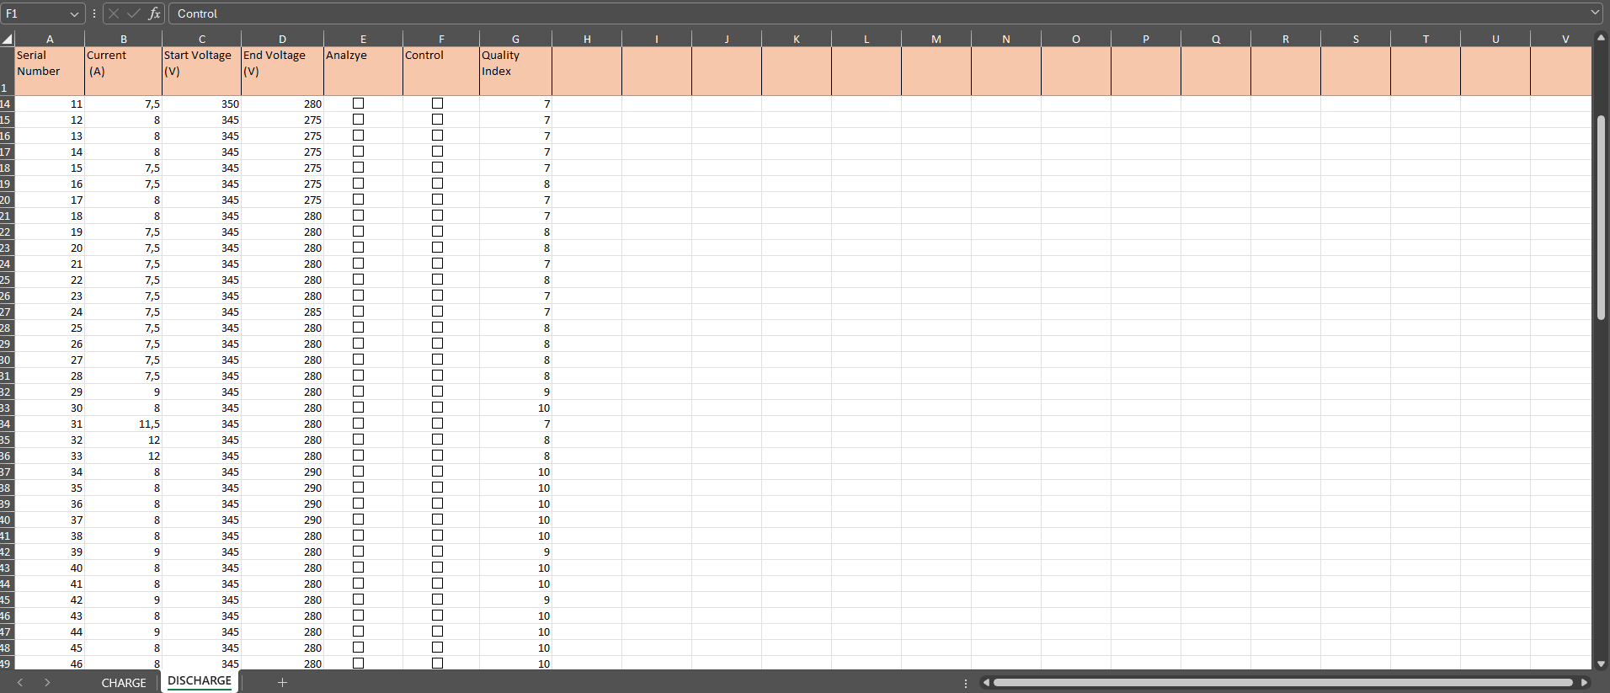

Data Analysis Algorithm
MATLAB was utilized to develop an algorithm for importing and analyzing data from the "Disch#36_10" folder.

1. Import battery data:
Name: LoadBatteryData
This MATLAB script processes multiple text files containing battery data. It prompts the user to select a directory, reads all .txt files within that directory, and stores the data in a cell array. Each file's data is converted to milliseconds, and consistency in column structure is ensured. Finally, the processed data is saved as a .mat file named batteryData.mat
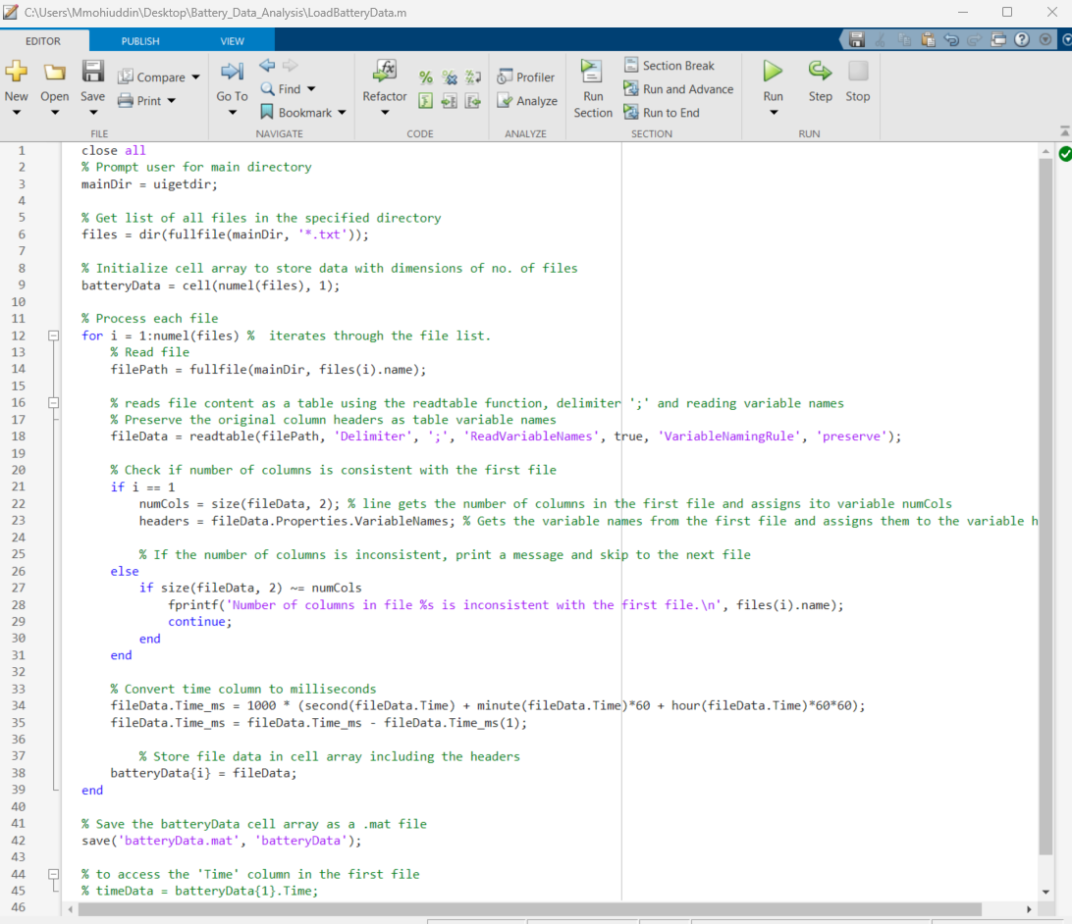

2. Import battery data plot
Name: Import_Battery_Data_plot
This MATLAB script prompts the user to input a desired file number from the previously processed battery data. It then extracts the data corresponding to the chosen file and converts time from milliseconds to hours, along with scaling several voltage and current values.
Subsequently, it plots four subplots in a single figure, each representing a different aspect of the battery data:
- Current vs. Time
- Battery Voltage vs. Time
- System Voltage vs. Time
- Second System Voltage vs. Time
The script ensures a visual representation of the chosen battery file's data for analysis.(see Fig1)
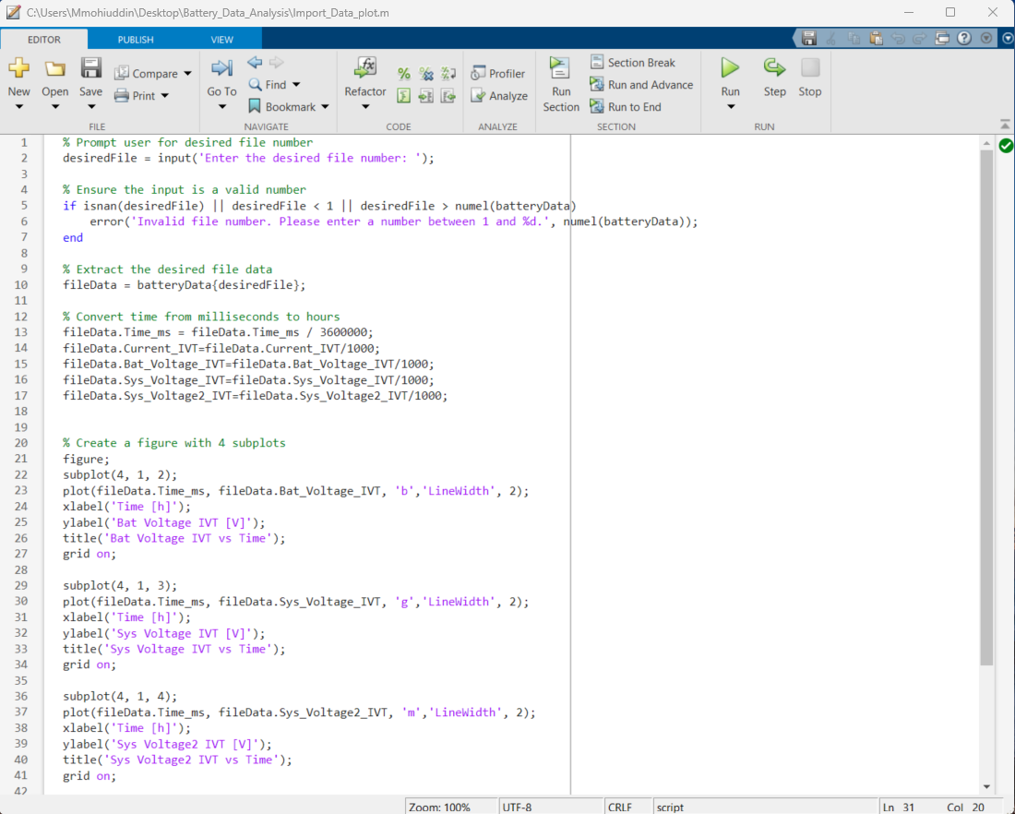
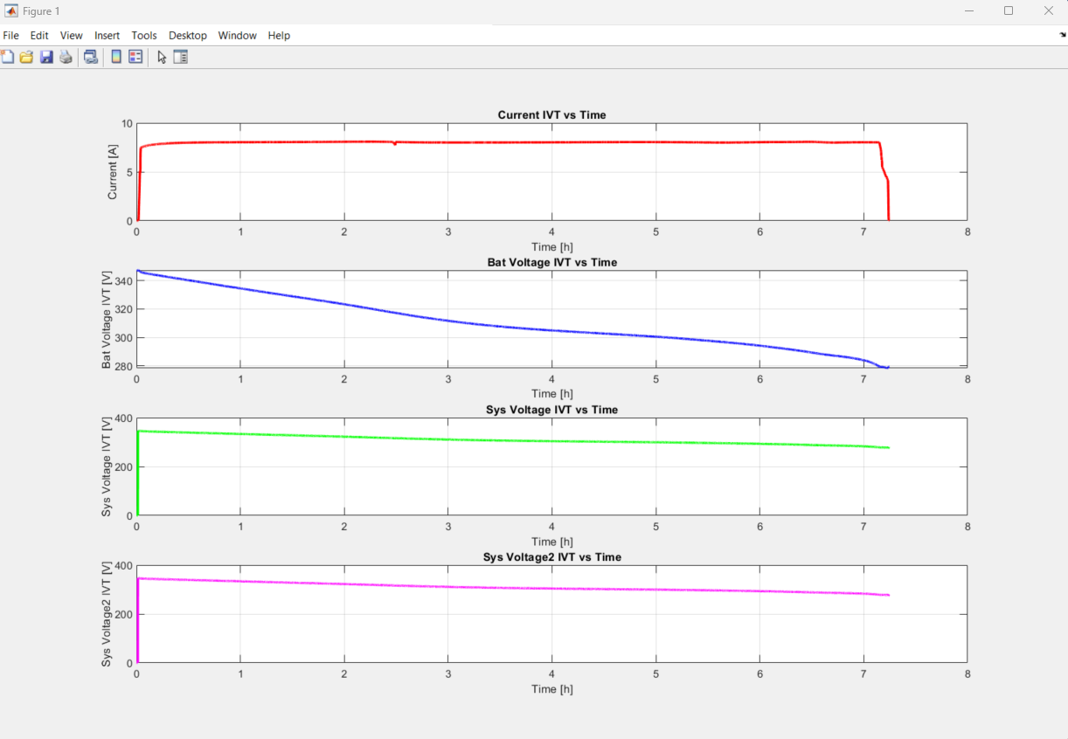
Fig 1

3. Interpolate and Plot
Name: PlotBatteryData

This MATLAB script interpolates and plots the battery data from multiple files. Here's a concise overview:
- Define Colors: Unique colors are generated using the hsv function for visualization.
- Interpolation Initialization: The maximum time value across all files is calculated to initialize the time vector for interpolation.
- Preallocation: Memory is preallocated for matrices storing interpolated data for each measurement type.
- Interpolation Loop: Interpolation is performed for each measurement type based on a common time vector.
- Plotting: Interpolated data is plotted in four subplots:
  - Current IVT vs. Time
  - Battery Voltage IVT vs. Time
  - System Voltage IVT vs. Time
  - Second System Voltage IVT vs. Time
Each subplot displays data from multiple files with unique colors.
- Axis Adjustment: The x and y-axis ranges are adjusted using xlim and ylim functions to ensure uniform display of data across subplots.
This script provides a comprehensive visualization of interpolated battery data, aiding in comparative analysis across multiple files.(see Fig 2)
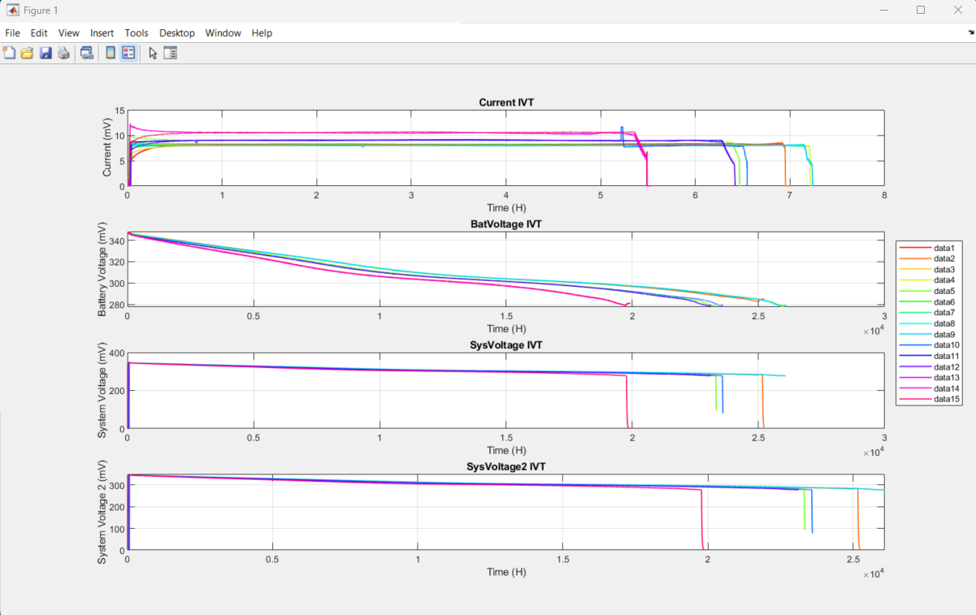
Fig 2

4. Plot Energy VS Voltage
Name: PlotEnergyvsVolt
This script segment performs several operations on battery voltage and current data, generating plots of energy against voltage for each battery in the batteryData array. Here's a concise overview:
- Color Generation: Unique colors are generated based on the number of elements in the batteryData array using the HSV color space.
- Interpolation: Voltage and current data are interpolated at a new time vector with a specified time step dt.
- Power, Energy, and Capacity Calculation: Power, cumulative energy, and capacity are calculated based on the interpolated voltage and current data.
- Figure Initialization: A figure is initialized for plotting energy against voltage.
- Plotting: Energy is plotted against voltage for each battery in the batteryData array. The plot is generated with lines of unique colors representing each battery.
This script provides a visualization of energy versus voltage for each battery, aiding in the comparative analysis of battery performance.(see Fig 3)
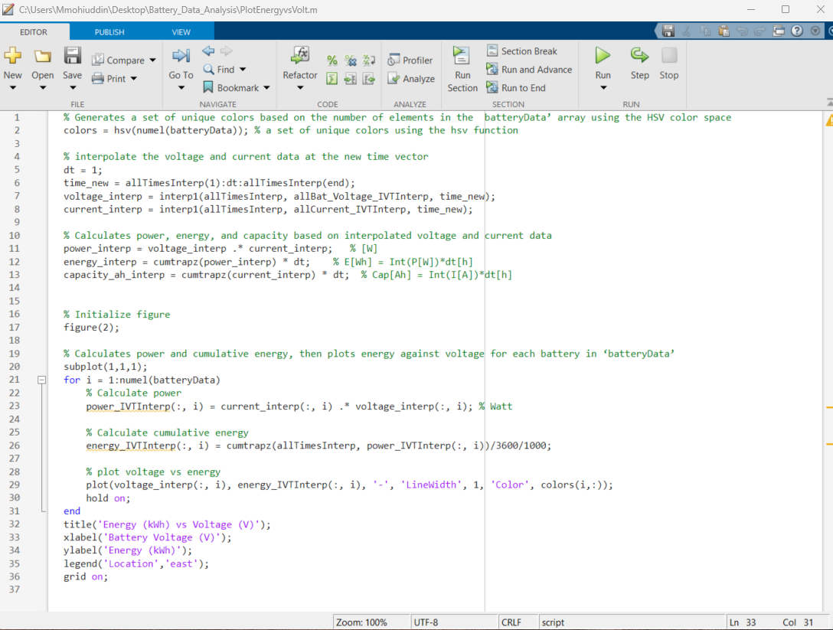
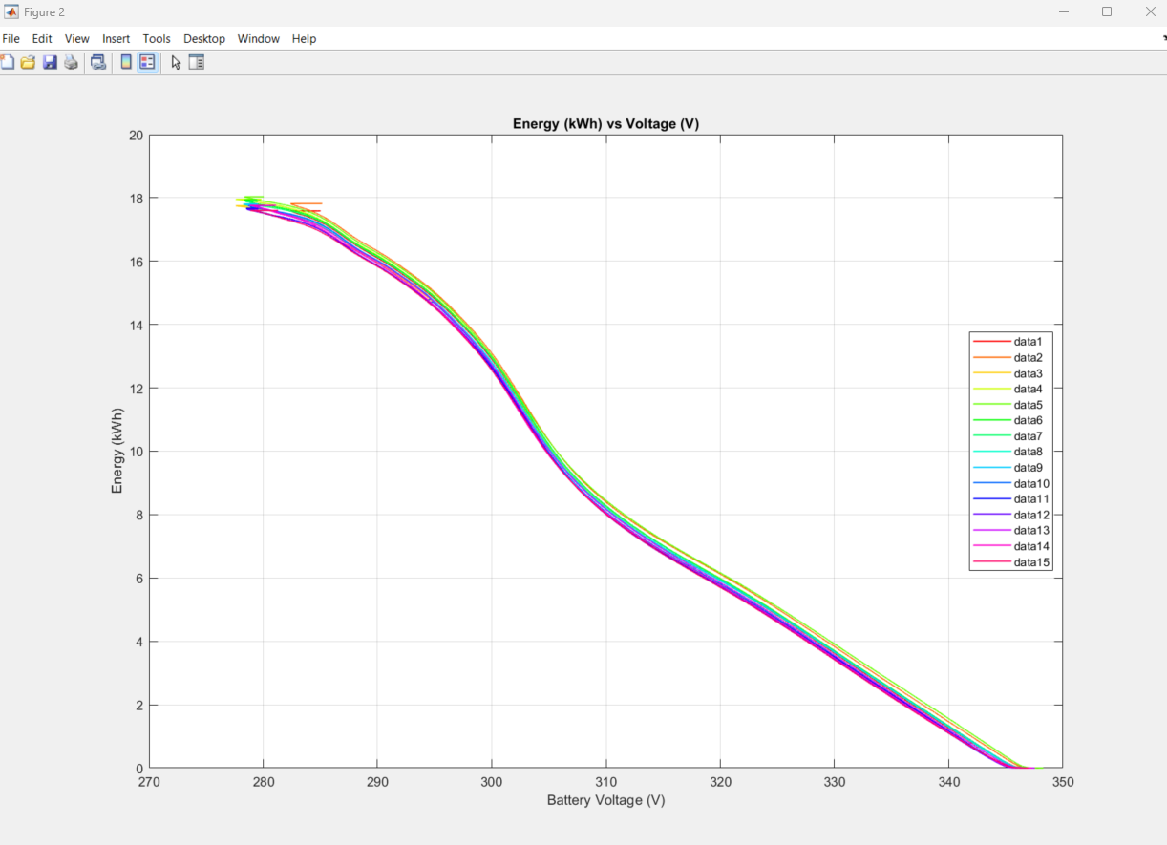
Fig 3

5. Plot Energy VS Voltage Customized
Name: PlotEnergyvsVoltcustom

This script segment prompts the user to input the minimum and maximum values for the voltage axis. It then interpolates the voltage values with a step size of 0.1 within the specified range. The script initializes a figure for plotting energy against voltage and performs the following operations:
- Data Filtering: Voltage and energy data are filtered based on the user-input minimum and maximum voltage values.
- NaN Removal: NaN values are removed from the filtered voltage and energy data.
- Duplicate Removal: Duplicate voltage values are removed, and corresponding energy values are adjusted accordingly.
- Energy Interpolation: Energy values are interpolated corresponding to the interpolated voltage values.
- Plotting: Interpolated voltage versus energy is plotted for each battery in the batteryData array, with lines of unique colors representing each battery.
- Axis Adjustment: The x-axis limits are set based on the user-input minimum and maximum voltage values. (e.g. min 290 max :345)
This script segment provides a customized plot of energy versus voltage for each battery, allowing users to focus on specific voltage ranges for analysis.(see Fig 4)

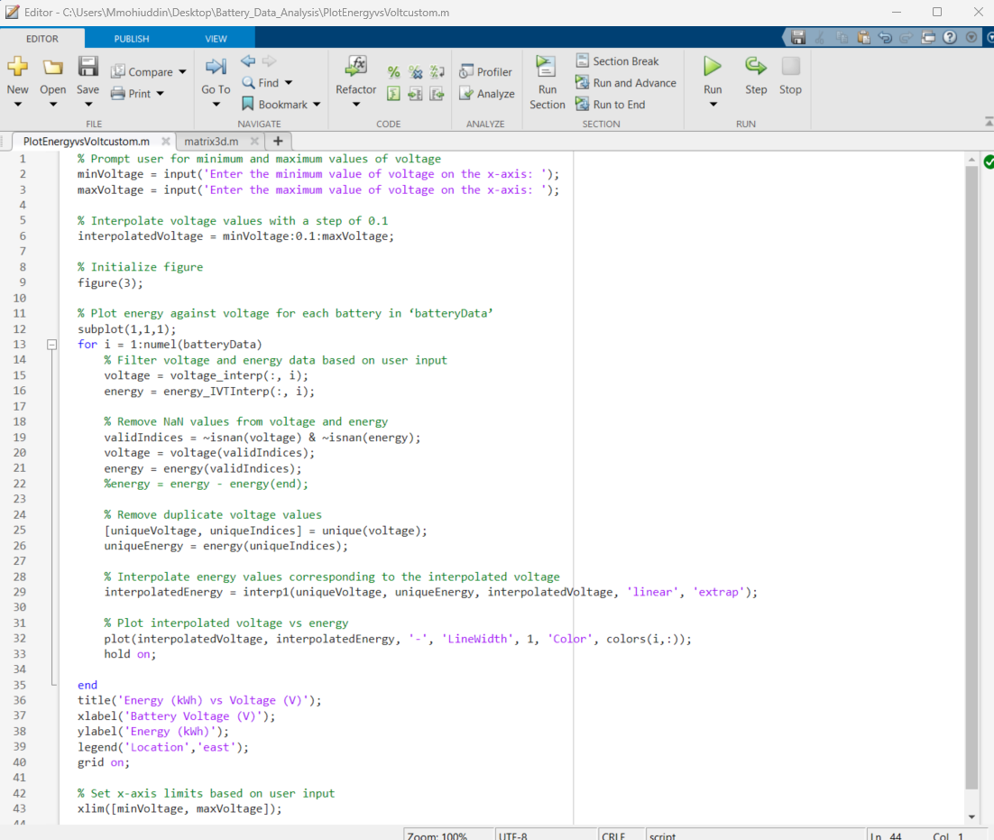
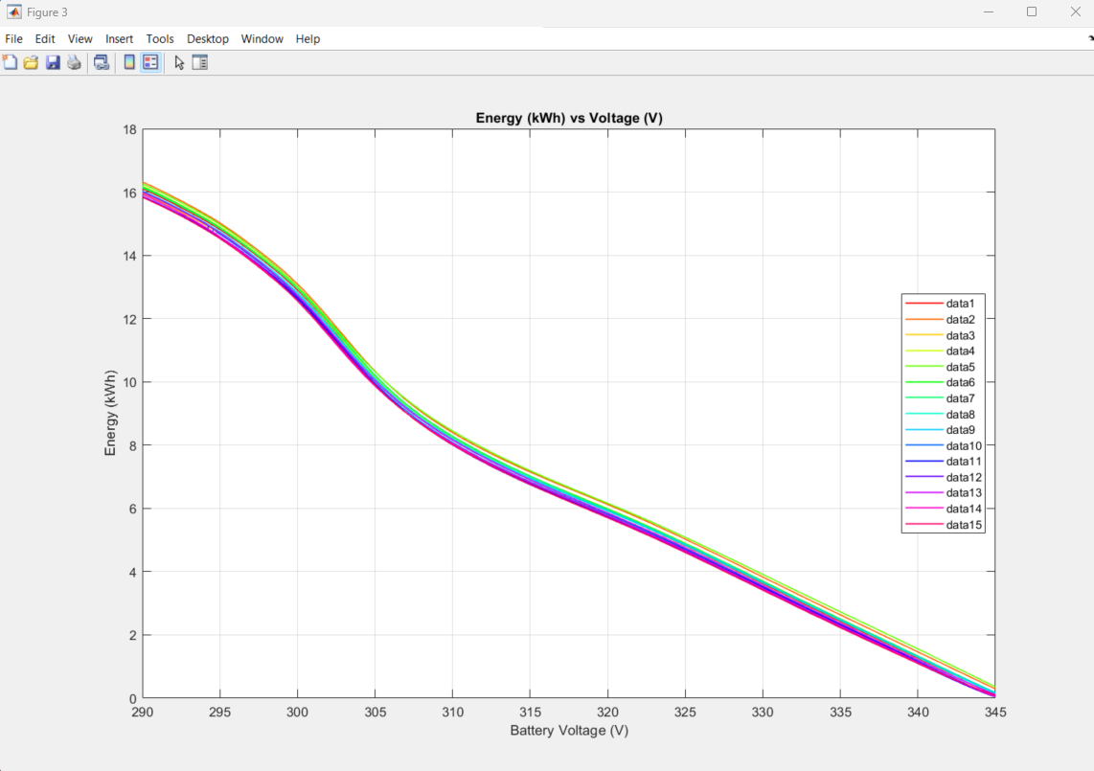
Fig 4
6. Matrix 3D
Name: matrix3d
- Data Initialization:
  - The script initializes a 3D matrix with dimensions representing files, variables (energy, power, current), and voltage values within the specified range.
  - It calculates the number of voltage values based on the specified range and a step size of 0.1.
- Data Population:
  - For each file in batteryData, voltage and current data are interpolated at a new time vector.
  - Power, energy, and capacity are calculated based on the interpolated voltage and current data.
  - Data is filtered based on the specified voltage range, and only relevant data points are retained.
  - Filtered data is stored in the 3D matrix.
- Matrix Size Display:
  - Finally, the script displays the size of the data matrix, indicating the number of files, variables, and voltage values stored.
This script segment provides a systematic approach to organize and store battery data within a specific voltage range for further analysis.
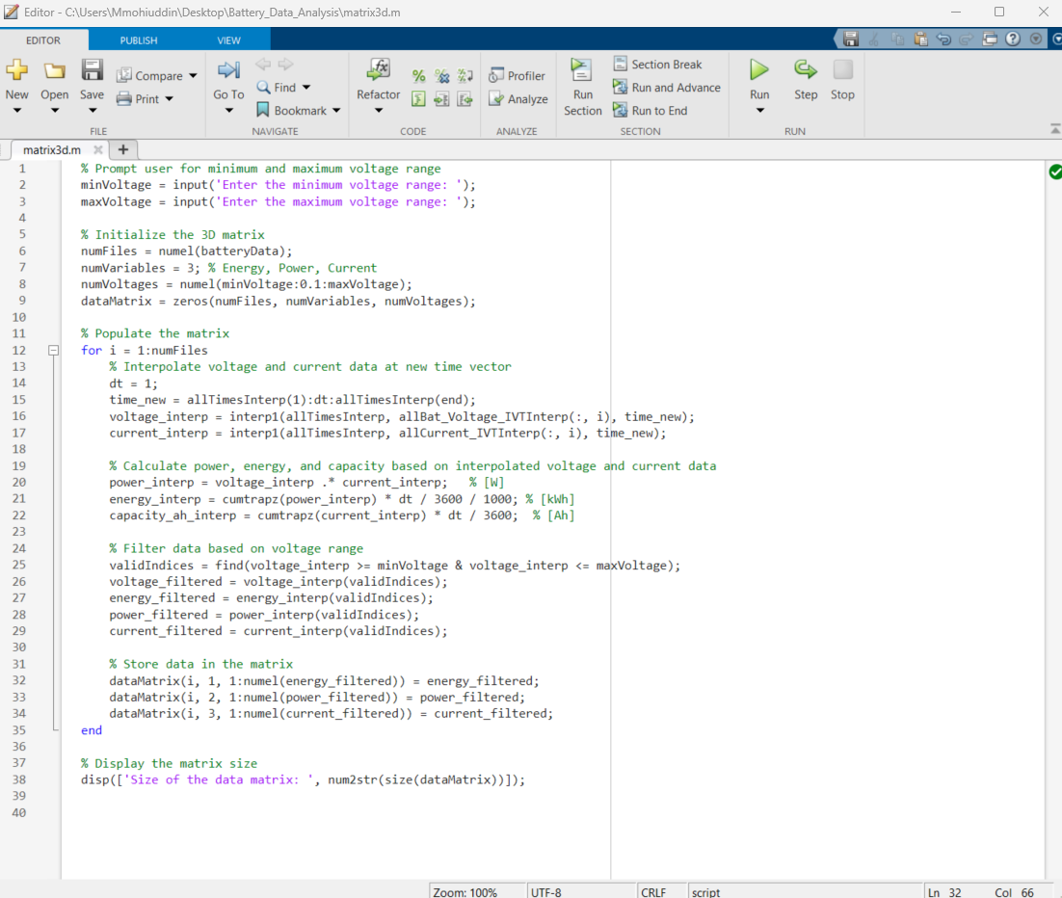

In conclusion, the provided MATLAB scripts form a cohesive workflow for analyzing battery data. Here's a concise summary: Overall, this series of MATLAB scripts offers a comprehensive approach to battery data analysis, enabling users to extract meaningful insights and make informed decisions regarding battery performance and optimization

